**Assignment 04 (Amrutesh)**

1. **What exactly is []?**

Ans: In programming language [] indicate the empty list , list is the collection of items where each element can be any data type like , integer, float, string, or other objects

**2.** **In a list of values stored in a variable called spam, how would you assign the value ‘hello’ as the third value? (Assume [2, 4, 6, 8, 10] are in spam.)**

**Ans** : 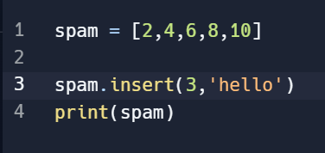

We can add values to list in specific index by using **‘insert’** method

**‘insert’**  takes two arguments; the first is index value and the second is the value to new elements we want to add

**Let’s pretend the spam includes the list ['a','b','c','d'] for the next three queries.**

**3.What is the value of spam[int(int(‘3’ * 2) / 11)]?**

**Ans:** Here in the above problem

Lets consider: int(‘3’*2)

By concatenation >>>>>>> (“‘33’’) and is converted to integer so : int (‘3’*2) is **33**

Again>>> int[33/11] is **3**

So value of spam is [3]

Ans is ‘d’

**4.** **What is the value of spam[-1]?**

**Ans :** The value of spam[-1] is **‘d’**

**5.** **What is the value of spam[:2]?**

**Ans:** The value of spam [:2] >>>>>>>>---- [‘a’,’b’]

**Let’s pretend bacon has the list [3.14, ‘cat’ , ‘11’ , ‘cat’ , True] for the next three questions.**

**6. What is the value of bacon.index(‘cat’)**

**Ans :** The index value of bacon.index(‘cat’) is [1]

**7.** **How does bacon.append(99) change the look of the list value in bacon?**

**Ans : bacon = [3.14, ‘cat’ , ‘11’ , ‘cat’ , True , 99]**

**8.** **How does bacon.remove(‘cat’) change the look of the list in bacon?**

**Ans : bacon = [ 3.14, ‘11’ , ‘cat’ , True ]**

**9.** **What are the list concatenation and list replication operators?**

**Ans: List Concatenation (+ operator):**

**We can use the + operator to concatenate two or more lists together into a new list. When we use the + operator to concatenate two lists, a new list is created that contains all the elements of the first list, followed by all the elements of the second list. Example :**

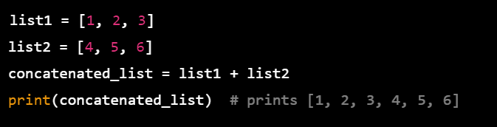

**List Replication (* operator):**

**we can use the * operator to replicate a list a specified number of times. When we use the * operator to replicate a list, a new list is created that contains the original list repeated the specified number of times.**

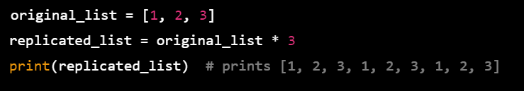

**10.** **What is difference between the list methods append() and insert()?**

**Ans : append() : Here the element is added to the last value if we append the list**

**Insert() : Here the insert take two arguments like the index value and the second is value to new element**

**11.** **What are the two methods for removing items from a list?**

**The remove() method:**

**The remove() method removes the first occurrence of a specified element from the list. If the element appears multiple times in the list, only the first occurrence is removed. The syntax for using the remove() method is:**

**>>>>>>>>>>>mylist.remove(element)**

**The pop() method:**

**The pop() method removes the item at a specified index from the list and returns its value. If you don't specify an index, it removes and returns the last item in the list. The syntax for using the pop() method is:**

**>>>>>>>>>>mylist.pop(index)**

**12.** **Describe how list values and string values are identical.**

**Ans**: **1) Indexing and Slicing:**

**Both lists and strings allow you to access individual elements or groups of elements using indexing and slicing. In both cases, you can use square brackets to access a specific element or slice of elements from the sequence**

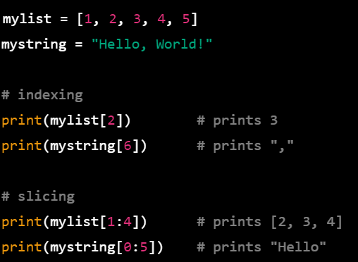

**2 Mutable vs. Immutable:**

**Lists and strings differ in one major way: lists are mutable, while strings are immutable However, both lists and strings allow you to reassign a value to a specific index**

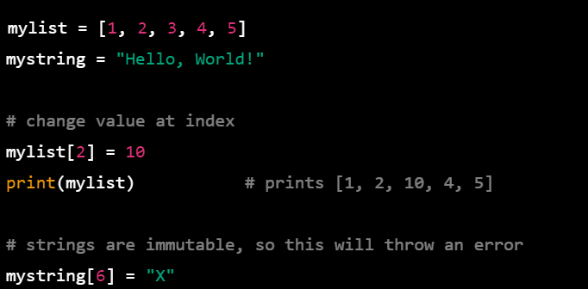

1. **Length**

**Both lists and strings have a length property that tells you how many elements are in the sequence. You can use the len() function to get the length of a list or a string**

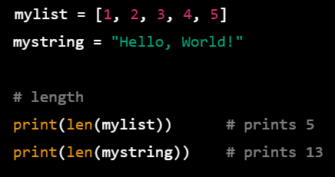

**13. What’s the difference between tuples and lists?**

**Ans : mutability :**

**One of the biggest difference is lists are mutable and tuples are immutable**

**In list we can add , remove and modify its elements but in tuples we cannot modify**

**syntax**

**The syntax to create tuple is to enclose the values in parenthses (),**

**The syntax to create lists is to enclose the values in square brackets.**

**Performance:**

**Its more memory efficient than using the list and even faster additionally since tuples are immutable they are used as keys in dictionaries, while lists cannot**

**14.How do you type a tuple value that only contains the integer 42?**

**Ans: tuple = (42,)**

**It is necessary to give trailing comma , without comma python would interpet the parenthses as an expression**

**15.** **How do you get a list value’s tuple form? How do you get a tuple value’s list form?**

**Ans : To convert a list into a tuple, you can use the tuple() function, which takes a single argument that is a sequence (such as a list) and returns a new tuple object that contains the same elements in the same order**.

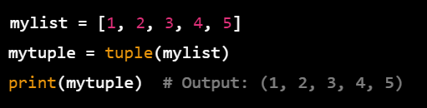

**To convert a tuple into a list, you can use the list() function, which takes a single argument that is a sequence (such as a tuple) and returns a new list object that contains the same elements in the same order**.

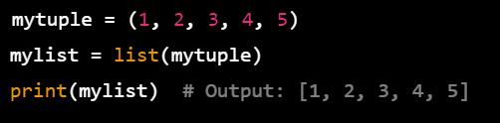

**16.** **Variables that contains list values are not necessarily lists themselves. Instead, what do they contain?**

**Ans :** **Variables that "contain" list values in Python are actually just references to list objects**

**When you create a list in Python and assign it to a variable, the variable doesn't actually contain the list data itself. Instead, it contains a reference to the location in memory where the list data is stored**

**This means that variables that contain list values are not necessarily lists themselves, but rather they are just references to list objects**.

17. How do you distinguish between copy.copy() and copy.deepcopy()?